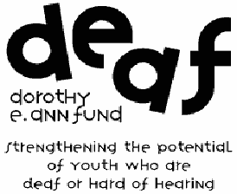
Teacher Mini-Grant Evaluation Form
The Dorothy E. Ann (D.E.A.F.) Fund is pleased to have made a grant to support your teaching activities and looks forward to receiving a summary of your activities this past year.
We would appreciate answers to the questions below, as well as any additional information
that would be essential to report your progress. Please type the evaluation and attach supporting materials such as pictures, flyers, and receipts to verify use of the funds.
Your report should include the teacher name, e-mail address, school district, as well as teacher and supervisor signatures and titles indicating all information is true to the best of your knowledge. The report is due on or before the first business day in June following the conclusion of your project.
Report of Grant Activities
- Describe your project. How many deaf or hard-of-hearing students were served with this project? How many hearing students? When did the project start? End?
- List the activities and materials/or that were supported by the Dorothy E. Ann (D.E.A.F.) Fund. List those activities or materials that will continue to be part of your classroom curriculum or school activities now that your project has ended.
- List the outcomes of the project. Explain how the potential of the deaf or hard-of-hearing students was strengthened.
- What were the main strengths of the project?
- What was the main weakness of the project?
- List how the awarded funds were spent. Please attach receipts.
Should you have any questions concerning this reporting outline, please contact Emily Savors at esavors@columbusfoundation.org or 614/251-4000. Please e-mail your final report by the first business day in June following the conclusion of your project to esavors@columbusfoundation.org.
The Columbus Foundation · 1234 East Broad Street · Columbus, Ohio 43205 · tel 614/251-4000 · fax 614/251-4009
www.columbusfoundation.org

